|  |  |  |
| --- | --- | --- |
| **SANTA CLARA UNIVERSITY** | **ELEN 115 Spring 2023** | **Shoba Krishnan** |
| **Project 2: Power Supply Design** | | |

# OBJECTIVES

* To design of a DC power supply.
* To construct the circuit in the laboratory and record sufficient measurements to establish circuit operation in accordance with design objectives.

# Analysis

The need exists for a small 5 VDC power source capable of delivering a load current to a 2.5K resistive load**.**

1. **Rectifier Design:**

It is decided to use a half-wave rectifier using 1N 4001 diode with a simple capacitor filter as shown in Fig.1.

The input voltage is obtained from a transformer that gives a 120Vrms 60 Hz sinusoid at the primary and a 31.8V peak to peak across the secondary (keeping the center tap floating).

* 1. Find the value of the load current for the given specifications
  2. Identify the turns ratio of the transformer
  3. Find the value of the capacitor needed to obtain a peak to peak ripple of 2V.

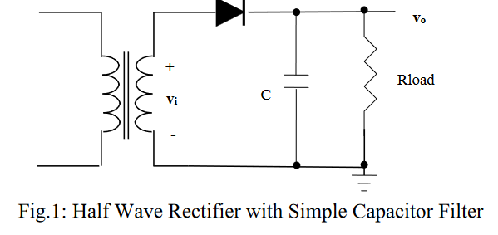

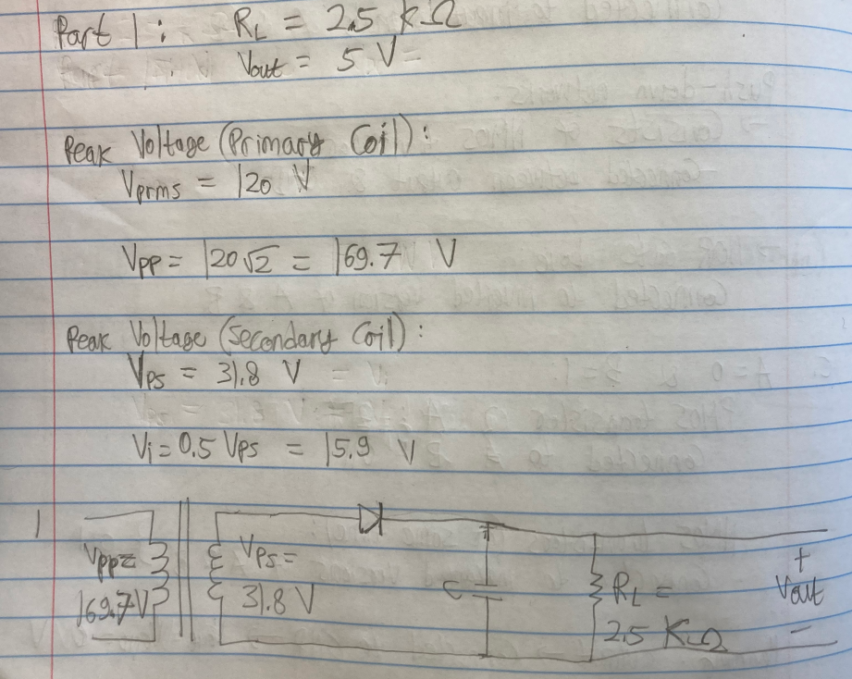

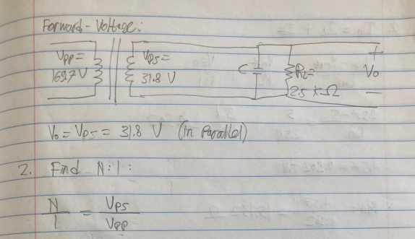

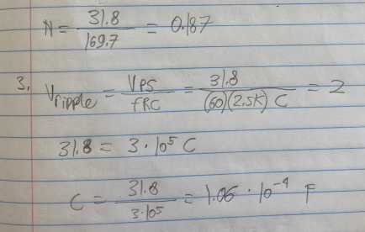

1. **Regulator:**

In order to reduce the ripple voltage applied to the load without increasing the size of the filter capacitor, it is decided to use a 5.1 volt Zener diode (1N751A) with the original design as shown in Fig. 2.

**v**

**o**

Rload

**v**

**i**

**+**

**-**

C

D

Z

I

L

R

Fig.2: Power supply Design with Zener Regulator

* + 1. Look up the Zener diode data sheet to obtain the dynamic zener resistance and test data point.
    2. Determine a value for R that will supply the maximum required load current of calculated from part 1 to the resistive load and provide a minimum Zener current of 3.5mA.

**Hint: Use minimum supply voltage, minimum Zener current and maximum load current when finding the R value.**

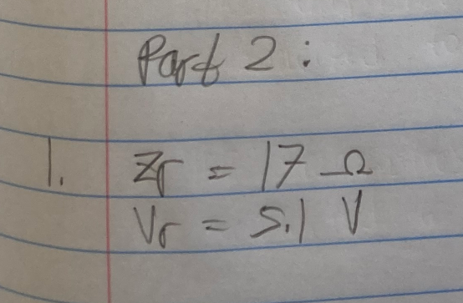

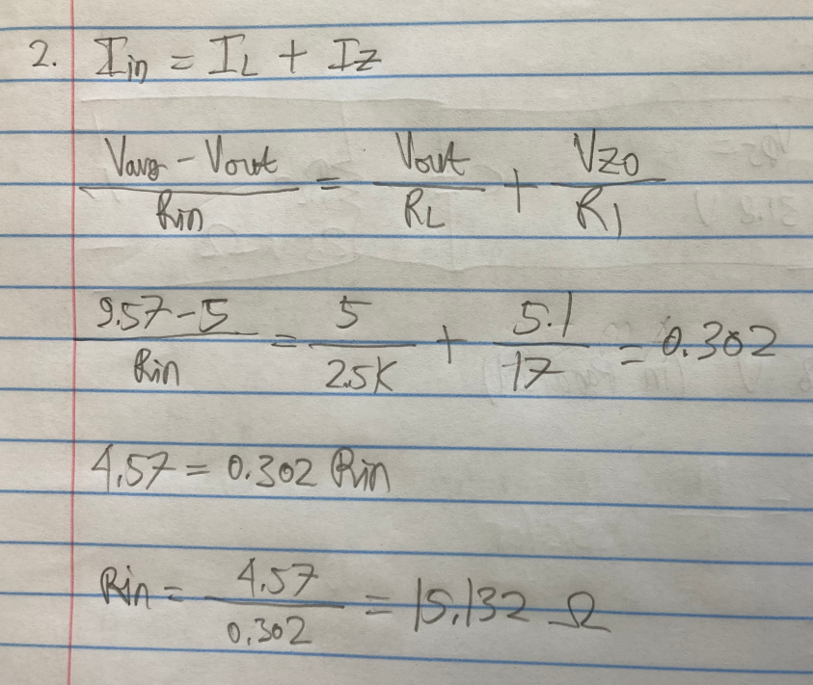

**Develop a test plan by answering the below questions**

1. How would you ensure that the rectifier action is happening?

I would measure the output waveform using an oscilloscope. The output waveform should be only occurring in one direction.

Half-Wave Rectifier Circuit:

1. Output Waveform should only have positive half-cycles.
2. No negative half-cycles

If somehow both positive and negative cycles are depicted the output waveform, then there might be a sign of a case where the rectifier circuit is faulty or not functioning properly. Only then, I would have to check where the errs are.

1. How would you know if the ripple specifications are being met?

I would again use oscilloscope to determine the output voltage of the power supply or voltage regulator. Then, compare the voltage ripple result with the specifications from the manufacturer. As long as voltage ripple (measured & AC) is less than the value given by the manufacturer, the ripple specifications are being met.

1. How would you know the load is getting the current it needs?

I would measure using ammeter or multimeter or oscilloscope across the load circuit. If the measured current value is similar to the expected current value, then I would know the load is getting the current it needs.

1. How would you measure the output voltage ripple and ensure it has improved after the zener shunt regulator has been added?

I would compare the oscilloscope peak-to-peak voltage measurement between before and after adding Zener shunt regulator. Since Zener shunt regulator's purpose is to decrease the ripple and fluctuations, the ripple after adding the Zener shunt regulator should be smaller than before adding the regulator.

1. How would you measure load regulation?

To measure load regulation, you need to measure the output voltage of the power supply or voltage regulator under different load conditions. Load regulation is a measure of how well the output voltage of the power supply or regulator remains constant as the load current changes.

To measure load regulation, follow these steps:

1. Connect the power supply or voltage regulator to the load and measure the output voltage with no load connected.
2. Connect a load resistor to the output of the power supply or voltage regulator and measure the output voltage again.
3. Increase the load current by changing the resistance of the load resistor, and measure the output voltage at each load current.
4. Calculate the change in output voltage as the load current changes. Load regulation is typically specified as a percentage of the output voltage change per unit change in load current.

Note:

Load regulation might be affected due to varying situations of the load, e.g., type of load and load current.

1. How would you find the maximum load current possible for this power supply?

To find the maximum load current possible for a power supply, you need to determine the maximum current that the power supply can provide while maintaining the specified output voltage.

Here are the steps to find the maximum load current possible for a power supply:

1. Determine the maximum power that the power supply can deliver. This can be found by multiplying the output voltage by the maximum output current. For example, if the output voltage is 12V and the maximum output current is 2A, then the maximum power that the power supply can deliver is 24 watts (12V x 2A).
2. Determine the efficiency of the power supply. The efficiency is the ratio of the output power to the input power. For example, if the input power is 30 watts and the output power is 24 watts, then the efficiency is 80% (24W / 30W).
3. Calculate the maximum input current that the power supply can draw. This can be found by dividing the maximum output power by the efficiency. For example, if the maximum output power is 24 watts and the efficiency is 80%, then the maximum input power is 30 watts (24W / 0.8), and the maximum input current is 2.5 amps (30W / 12V).
4. The maximum load current possible for the power supply is the minimum of the maximum output current and the maximum input current. For example, if the maximum output current is 2A and the maximum input current is 2.5A, then the maximum load current possible for the power supply is 2A.

Therefore, the maximum load current possible for this power supply is 2A, assuming that the power supply is operating at maximum efficiency and the input voltage is sufficient to support the output voltage and current. It is important to note that the actual maximum load current may be lower depending on the specific operating conditions and the requirements of the load.